Great Books to Put in Christmas Stockings - 2021

Recommended reads and new releases for middle grade and YA readers.

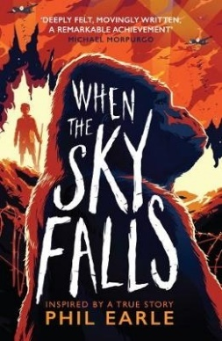 | This brilliant book, based on a true story, is set in London during the blitz. So much more than just a war story, it’s great for Year 7 – 9 (or confident Year 6s), but it deserves to be read by all ages.  ‘An extraordinary story with historical and family truth at its heart, that tells us as much about the present as the past. Deeply felt, movingly written, a remarkable achievement’ Michael Morpurgo
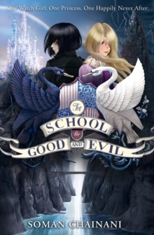 | “A dark and enchanting fantasy adventure perfect for those who prefer their fairy tales with a twist...”  The first in an uber popular series. Suitable for Year 7 onwards.
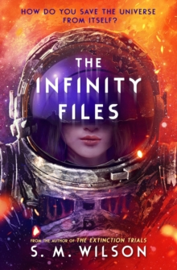 | Escape into space with the star-spangled new series from the author of The Extinction Trials, perfect for fans of Doctor Who. Get in. Get out. Keep to the task. Leave no trace. Ash Yang dreamed of being a starfighter pilot. But when she crashes out of her final test - literally - she somehow lands the most powerful job in the universe.  Great for Year 7+.
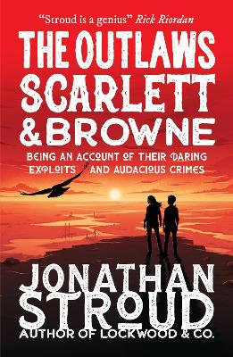 | Set in a broken, future England, where gunfights and monsters collide, this is the exciting first title in a phenomenal fantasy teen series by the bestselling children's novelist. Good for confident Year 7 readers but also for older children.

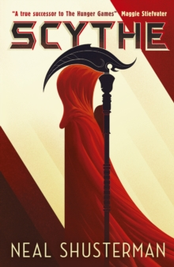 | In a future world where humans can theoretically live forever, it falls to the mysterious ‘Scythedom’ to take over the power of life and death. This may be a dark concept but it is a fascinating white-knuckle ride into a speculative future with surprises and OMG moments around every corner. It captures your attention early on and does not let go!  Great for Year 9 and upwards.
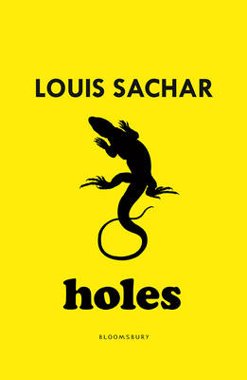 | First published in 1998, I suppose this uniquely humorous little book now counts as an “oldie”. That doesn’t stop it being brilliant though as frequent appearances on “best of all time” style lists attest. Suitable for Year 7 students but should be read by everyone.
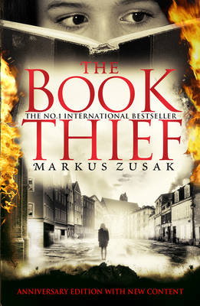 | Narrated by Death this is the now classic story of ordinary people living under the Nazi regime. An important, thought-provoking book but also a page turner. Aimed at both adults and children Year 9 and above.
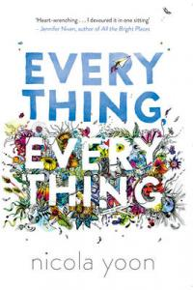 | “You only get one chance at first love. And Maddy is ready to risk everything, everything to see where it leads.”  A very popular book suitable for Year 9 and above.

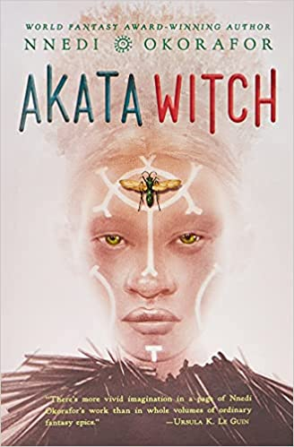 | “Affectionately dubbed the Nigerian Harry Potter, Akata Witch weaves together a heart-pounding tale of magic, mystery, and finding one's place in the world.”  “There's more imagination on a page of Nnedi Okorafor's work than in whole volumes of ordinary fantasy epics.” --Ursula K. Le Guin, award-winning author of A Wizard of Earthsea.  Great for Year 8 and above.
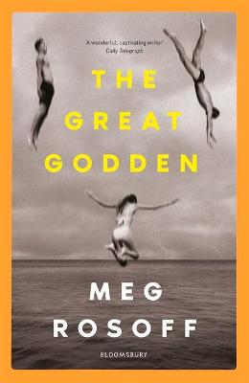 | The latest novel from the highly acclaimed author of ‘How I Live Now’ is a lyrical coming-of-age story about family and first love set over the course of a long, lazy summer. Satisfying for 6th Formers and suitable for mature Year 9s.
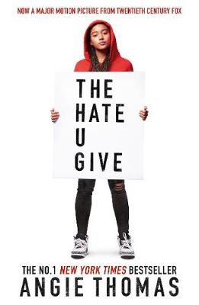 | “Sixteen-year-old Starr lives in two worlds: the poor neighbourhood where she was born and raised and her posh high school in the suburbs. The uneasy balance between them is shattered when Starr is the only witness to the fatal shooting of her unarmed best friend, Khalil, by a police officer…”  First published in 2017, this one is already deemed a classic of YA fiction. Suitable for Year 10 upwards.
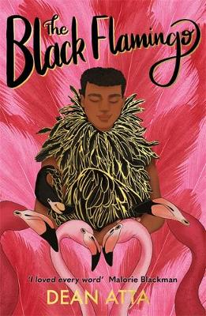 | “This is not about being ready, it's not even about being fierce, or fearless, IT'S ABOUT BEING FREE” (from the back cover).  “Uplifting and dazzlingly unique, this coming-of-age treasure explores identity and sexuality with an emboldening message to remember that “you have the right to be you” (from lovereading4kids.co.uk)  Suitable for Year 9 and above.

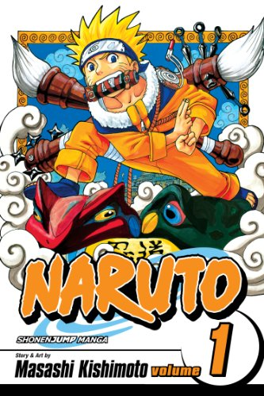 | If you are looking for a book to give to a child who is not a keen reader of traditional books, graphic novels and manga may be the way forward, and there is no more iconic manga than the Naruto series.  Graphic novels can act as a gateway to more traditional books with many authors reporting that they first got into reading via books such as this.  With over 70 volumes in the full series, Naruto is hoovered up by children in Year 7 and beyond.
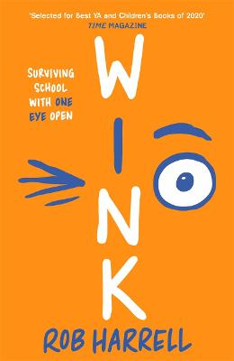 | “Twelve-year-old Ross is dealt a devastating blow when he’s told he has an extremely rare form of eye cancer and is likely to lose sight in both eyes. Based on author Rob Harrell’s personal experience of eye cancer, and spiced with his cool comic-strips of Ross’s Battbutt and Batpig characters, Wink has all the freshness and pitch-perfect narrative voice of a Louis Sachar story, with its own unique warmth and wit,” (from lovereading4kids.co.uk).  Great for fans of ‘Wonder’ and suitable for Year 7 upwards.
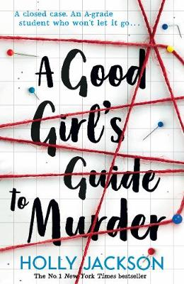 | Pippa Fitz-Amobi investigates a closed-case murder in her hometown under the guise of writing an EPQ. A brilliant twist-laden murder mystery for young adults. Year 9 and over.
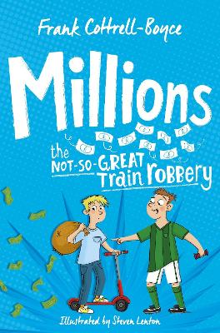 | Children who enjoy David Walliams and Roald Dahl should be introduced to the wonderful world of Frank Cotttrell- Boyce’s books as soon as possible. ‘Millions’ is a great place to start, but there are many other gems by the author.

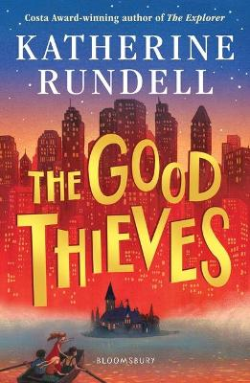 | This latest offering from the brilliant Katherine Rundell confirms her as one of the very best writers for children. Suitable for Year 7s or anyone who enjoys good writing, great stories, and unforgettable characters.
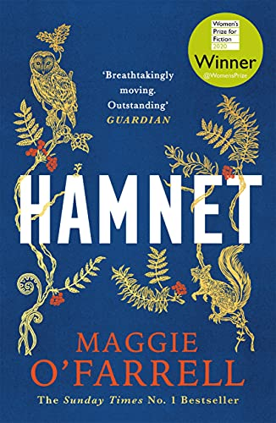 | All of life is in this book inspired by the Shakespeare family and the boy who gave his name to the most famous play ever written. About love and grief and about how a great artist tried to bring his son back to his family. Aimed at adults, suitable for Sixth Formers and mature Year 10 / 11s.
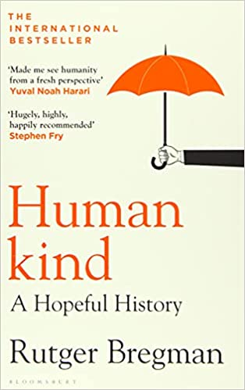 | A wide-ranging piece of historical and philosophical non-fiction that makes a compelling argument that perhaps human beings are, when the chips are down and contrary to popular opinion, actually quite nice. Fascinating, uplifting and surprisingly fun to read. Great for curious Sixth Formers.
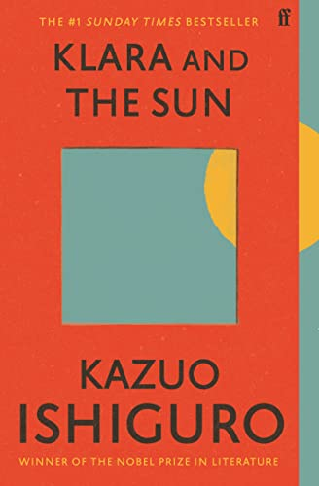 | Ishiguro uses the lens of an Artificial Intelligence to dissect the human heart and our rapidly changing world.  'This is a novel for fans of Never Let Me Go . . . tender, touching and true.' The Times  Aimed at adults, suitable for Sixth Formers.

